Market Manipulation Model

|  |  |  |
| --- | --- | --- |
| Market/Player | + | - |
| + | 3 | -2 |
| - | -2 | 1 |

$$P\left(M=+\right)=x$$

$$P\left(P=+\right)=y$$

$$E\left(P\right)=3xy+1\left(1-x\right)\left(1-y\right)-2x\left(1-y\right)-2\left(1-x\right)y=3xy+1-x-y+xy-2x+2xy-2y+2xy$$

$$=8xy-3x-3y+1$$

$$E\left(P\right)=8xy-3x-3y+1<0$$

$$\left(8x-3\right)y<3x-1$$

Case 1:

$$8x-3>0$$

Or,

$$x>\frac{3}{8}$$

$$y<\frac{3x-1}{8x-3}$$

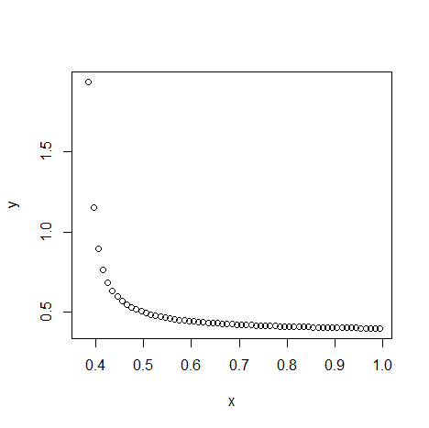

$$x=1$$

$$y=\frac{2}{5}$$

Case 2:

$$8x-3<0$$

Or,

$$x<\frac{3}{8}$$

$$y>\frac{3x-1}{8x-3}$$

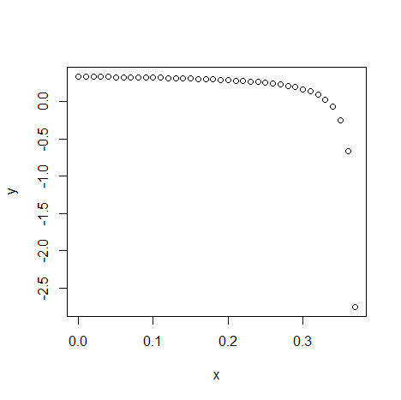

$$x=0$$

$$y=\frac{1}{3}$$

Conclusion

$$y∈\left[\frac{1}{3},\frac{2}{5}\right]$$

|  |  |  |
| --- | --- | --- |
| Market/Player | + | - |
| + | a | -b |
| - | -c | d |

$$P\left(M=+\right)=x$$

$$P\left(P=+\right)=y$$

$$a,b,c,d>0$$

$$E\left(P\right)=axy+d\left(1-x\right)\left(1-y\right)-cx\left(1-y\right)-by\left(1-x\right)$$

$$=axy+d-dx-dy+dxy-cx+cxy-by+bxy$$

$$=\left(a+b+c+d\right)xy-\left(d+c\right)x-\left(d+b\right)y+d$$

$$=\left[\left(a+b+c+d\right)x-\left(d+b\right)\right]y-\left[\left(d+c\right)x-d\right]<0$$

$$\left[\left(a+b+c+d\right)x-\left(d+b\right)\right]y<\left(d+c\right)x-d$$

Case 1:

$$\left(a+b+c+d\right)x-\left(d+b\right)>0$$

$$\left(a+b+c+d\right)x>\left(d+b\right)$$

$$x>\frac{d+b}{a+b+c+d}$$

$$y<\frac{\left(d+c\right)x-d}{\left(a+b+c+d\right)x-\left(d+b\right)}$$

Case 2:

$$\left(a+b+c+d\right)x-\left(d+b\right)<0$$

$$\left(a+b+c+d\right)x<\left(d+b\right)$$

$$x<\frac{d+b}{a+b+c+d}$$

$$y>\frac{\left(d+c\right)x-d}{\left(a+b+c+d\right)x-\left(d+b\right)}$$